< District Playground Management System (DPMS) >
Design Document

Version 1.0



Group Id: S200283999(MC190200859)
Supervisor Name : Sir Asif Hussain

Revision History
Date (dd/mm/yyyy) | Version | Description | Author
Current date | 1.0 | Introduction of the project | Write student(s) id
30.06.2021 |  | Design document is use to give a application development team overall guidance to the architecture of the application project. Design document contains ERD, Sequence Diagram, Architecture Design Diagram, Class Diagram, Interface Design and Test Cases. | MC190200859

Table of Contents

- Introduction of Design Document
- Entity Relationship Diagram (ERD)
- Sequence Diagrams
- Architecture Design Diagram
- Class Diagram
- Database Design
- Interface Design
- Test Cases

- Introduction of Design Document
In the SRS document, I focus on ‘What’ to do and in design phase the focus is shifted from ‘WHAT’ to ‘HOW’ to do. It means how the problem will be solved and which tools and techniques will be used. Much care is taken during the design phase because any mistake in this phase could be very expensive to solve in he later stage of the software development. The purpose of design phase is to plan out a system that meets the requirement defined in the analysis phase.
Entity Relation Diagram: It shows the relationship between two entities and properties of each entity. Two entities connect with each other by Test Case.
Sequence Diagrams: It shows the messages exchanges between entities.
Architecture Diagram: It shows different module called layers. Customer requests flow to the destination by passing different isolated layers.
Class diagram: It defines the properties and behavior of different classes and their relation is also mentioned in these diagrams.
Database diagram: In database design diagram the rows and columns which contain data are shown in the form of a table. The relation of different tables and field is shown in database design.
Interface Diagram: The interface diagram show that how does a system looks like and how is its front end. This diagram provides the interface of the system.
Test Cases: Finally On the basis of different Test Cases the test cases are created.
- Entity Relationship Diagram (ERD)

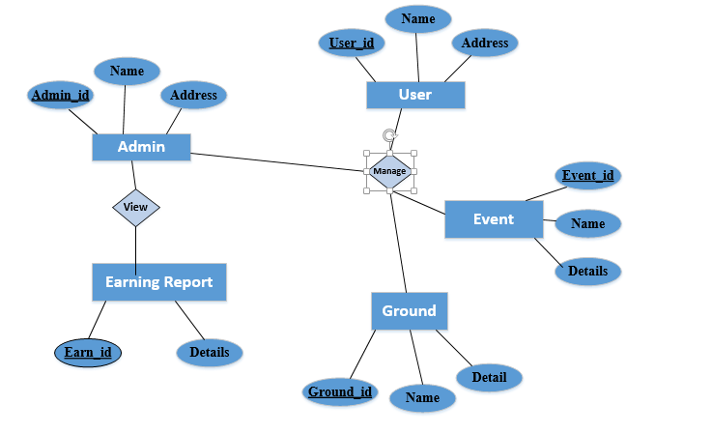
ERD Diagram Figure 1.0

Sequence Diagrams
Login:
Application
Database
Admin/User

Sign in ()

Okay
Login to account successfully
Login to Account

Add Ground:
Application
Database
Admin

Add Ground ()

Okay
Ground Added successfully
Start /Add Ground

Add/Book Event:
Application
Database
Admin/User

Booked ()

Okay
Event Add/Book successfully
Add/Book Event

Register User:
Application
Database
User

User Register ()

Okay
User Register successfully
Register Info

View Booking Info Daily / Weekly / Monthly:
Application
Database
User

View Info ()

Okay
Booking Info View successfully
View Booking Info

View Earning Info Weekly / Monthly/ Annually:
Application
Database
Admin

View Info ()

Okay
Earning Info View successfully
View Earning Info

Logout:
Application
Database
Admin/User

Logout ()

Okay
Logout
Successfully
Click logout

- Architecture Design Diagram
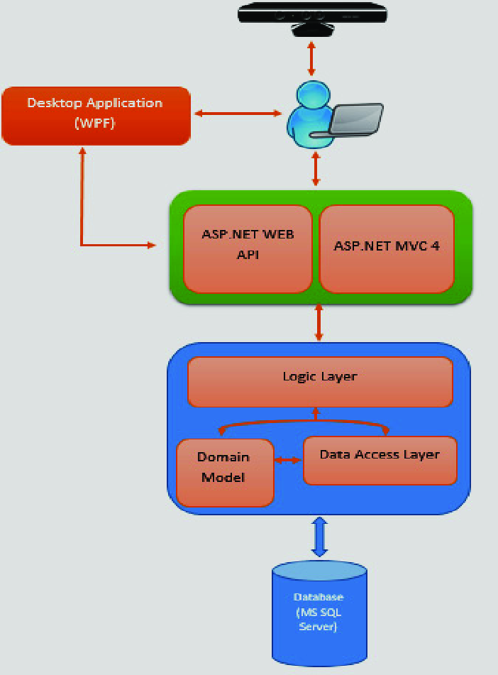
Architected Diagram Figure 3.0

- Class Diagram

Admin

-Admin_id
- name
-address

+addground ()
+ addbookin ()
+viewEarning ()
+managereport ()

User

-user_id
- name
-address

+register ()
+booking ()

Booking Event
Earning
Ground
-E_id
-detail

+manageEvent ()
+ViewEvent ()
-E_Id
- detail

+manageEarning ()
+viewEarning

- G_Id
-Name
-Details

+ManageGround ()

Class Diagram Figure 4.0

- Database Design

User
Admin

User_id int PK
Name varchar(50)
Address varchar(250)

Admin_id int PK
Name varchar(50)
Details varchar(250)

Earning

Ground

Booking Event

E_Id int PK
Name varchar(50)
Details varchar(250)

E_Id int PK
Detail varchar(50)

G_id int PK
Name varchar(50)
Detail varchar(50)

Database Diagram Figure 5.0

- Interface Design

Login
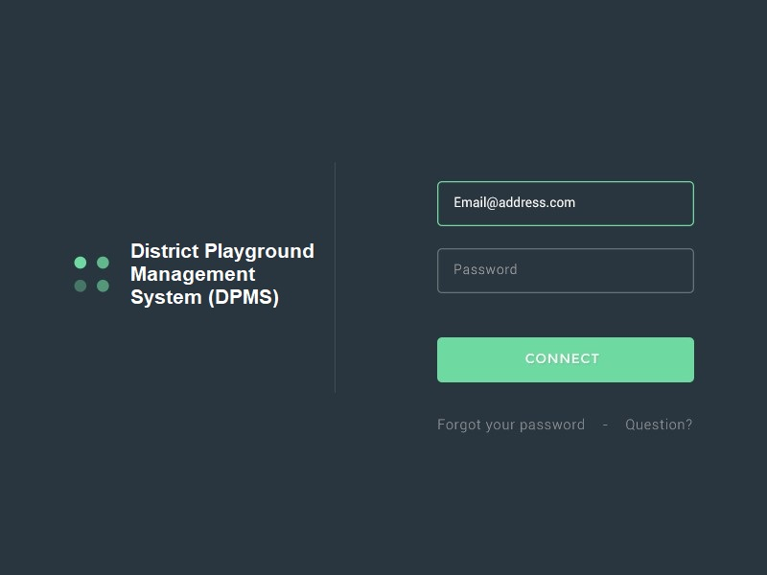

Interface Diagram Figure 6.0

Register Team
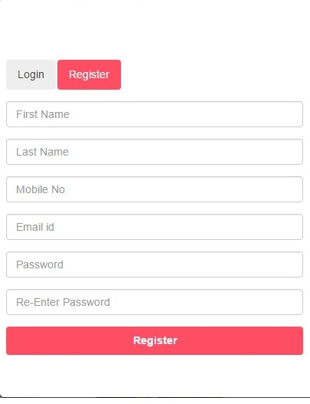
Interface Diagram Figure 6.1
Ground Info
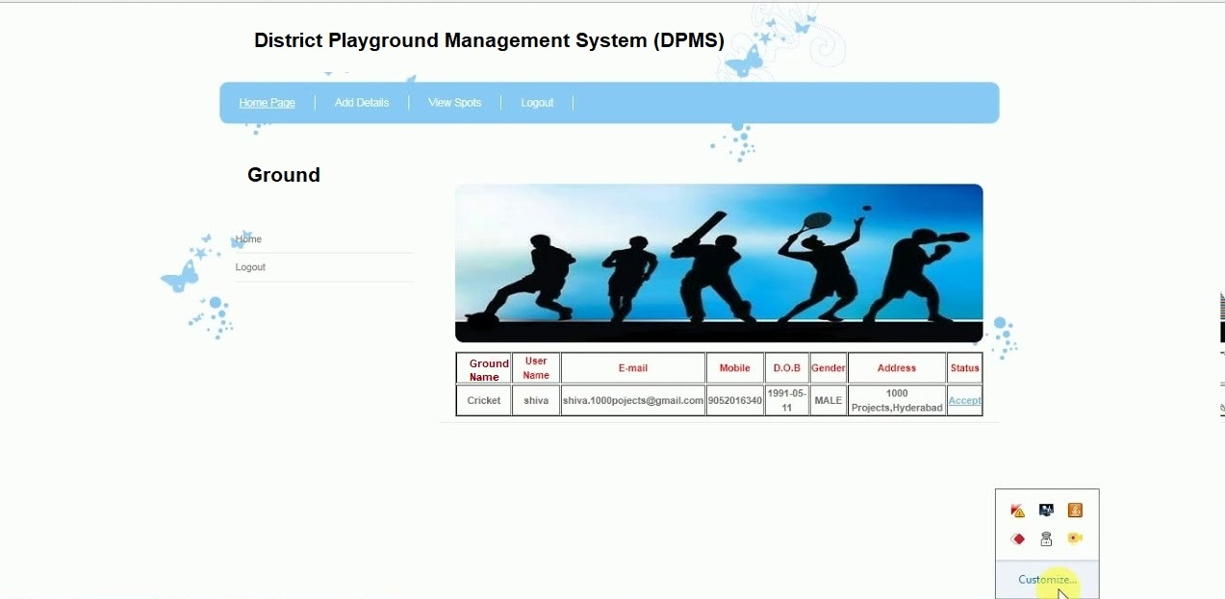
Interface Diagram Figure 6.2
Events Detail
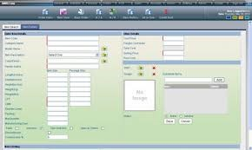
Interface Diagram Figure 6.3

View Reports
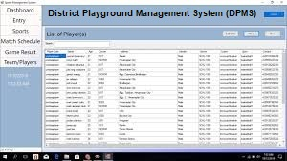

Interface Diagram Figure 6.4
- Test Cases

Test Case Title | Register
Test Case Id | 01
Description: The user can create a new account to Login into the Application.
Pre-Conditions:
  - Application must be in running condition.
  - Create New Account opt must be available.
Post Conditions:
A new User account is successfully created.
Unresolved issues: None
Authority: User
Modification history: 1.0
Author: < MC190205147 >
Result : Pass

Test Case Title | Login
Test Case Id | 02
Description: For using application, User and admin have to login.
Pre-Conditions:
- Application must be in running condition.
- Login page must be available
Post Conditions:
  - Account logged in successfully.
Unresolved issues: None
Authority: Admin, User
Modification history: 1.0
Author: <MC190205147>
Result : Pass
Test Case Title | Add Ground Info
Test Case Id | 03
Description:. Admin will add the detail of all the Ground like ground fee, type, number of slots in a day etc.
Pre-Conditions:
- Application must be in running condition.
- Add Ground Info option should be available.
Post Conditions:
Ground Info Added
Unresolved issues: None
Authority: Admin
Modification history: 1.0
Author: <MC190205147>
Result : Pass

Test Case Title | Add Event Booking
Test Case Id | 04
Description: Admin will add the details of all the booking of event.
Pre-Conditions:
- Application must be in running condition.
- Add Event Booking details
Post Conditions:
Event Booking Added.
Unresolved issues: None
Authority: Admin
Modification history: 1.0
Author: <MC190205147>
Result : Pass

Test Case Title | Register Team / Club
Test Case Id | 05
Description: Admin will register team/club assign a user who will conduct the particular sports activity.
Pre-Conditions:
- Assign user option should available
Post Conditions:
Register Team / Club successfully.
Unresolved issues: None
Authority: Admin.
Modification history: 1.0
Author: <MC190205147>
Result : Pass
Test Case Title | Display/Check/Print Booking Info Day/Weekly/Monthly
Test Case Id | 06
Description: Admin, User can Display/Check/Print Booking Info Day/Weekly/Monthly.
Pre-Conditions: .
- Admin, User must be logged in into his/her account
- View Check, Print option.
Post Conditions:
Check, Print and Viewed successfully.
Unresolved issues: None
Authority: Admin, User
Modification history: 1.0
Author: <MC190205147>
Result : Pass

Test Case Title | Display/Check/Print Earning Info Weekly/Monthly/Annually
Test Case Id | 07
Description: In admin, user’s panel, user will Display/Check/Print Earning Info Weekly/Monthly/Annually activity.
Pre-Conditions:
- Application must be in running condition.
2. Display/Check/Print Earning Info Weekly/Monthly/Annually

Post Conditions:
Display/Check/Print Earning Info Weekly/Monthly/Annually successfully.
Unresolved issues: None
Authority: Admin, User
Modification history: 1.0
Author: <MC190205147>
Result : Pass

Test Case Title | Logout
Test Case Id | 10
Description: Admin and user can logout from the Application.
Pre-Conditions:
- Admin and user log out from the Application.
Post Conditions:
Action Performed Successfully
Unresolved issues: None
Authority: Admin, User
Modification history: 1.0
Author: <MC190205147>
Result : Pass

